Andrew Rutherford

CSCI 3287

Assignment 4

13.2.1.c

1 + 0.0002n where n = (100,000 – 1)

1 + 0.0002(999,999) = ~200.9998ms = 201ms.

13.2.1.e

Degrees = ((63/1000) * 20% + (64/1000) * 80%) * 360 degrees = 22.9 degrees

(22.9/360) * 10 = 0.636ms

13.3.1.a, b

|  |  |  |  |
| --- | --- | --- | --- |
| Cylinder of Request | First Time Available | Elevator | FCFS |
| 8000 | 0 | 1 + (24000) / 4000 + 4.3 = 11.3 | 11.3 |
| 48000 | 1 | 11.3 + 1 + (40000) / 4000 + 4.3 = 26.6 | 11.3 + 1 + (40000) / 4000 + 4.3 = 26.6 |
| 4000 | 10 | 33.9 + 1 + (36000) / 4000 + 4.3 = 48.2 | 26.6 + 1 + (44000) / 4000 + 4.3 = 42.9 |
| 40000 | 20 | 26.6 + 1 + (8000) / 4000 + 4.3 = 33.9 | 42.9 + 1 + (36000) / 4000 + 4.3 = 57.2 |

14.1.1.a

n/3 blocks for data file, n/10 for the index

Total = 13n/30 blocks

14.1.1.b

n/3 blocks for data file + n/30 = 11n/30

14.2.1.a

Total: 100000 + 14286 + 204 + 3 + 1 = 114494

5 I/Os for a lookup because the tree has 4 levels

14.3.1.i

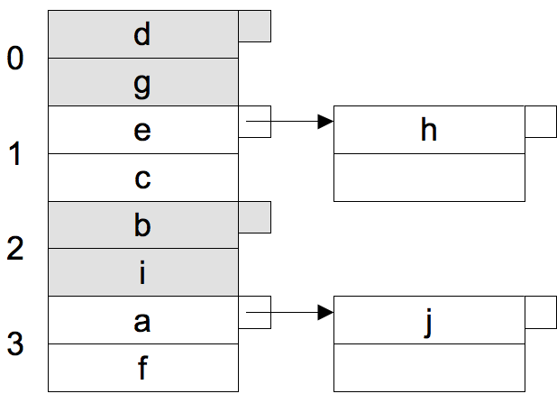

14.3.1.ii

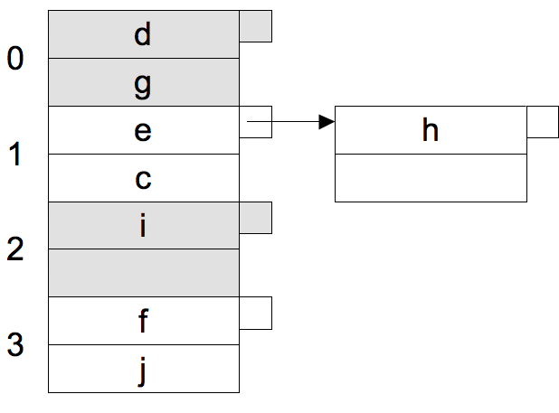

14.3.1.iii

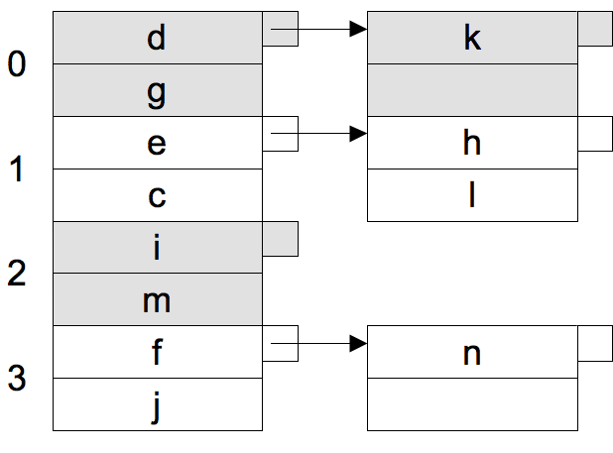

14.3.1.iv

